**Student Name: Venkata Ramana Voddam Pudi Sankar**

**Student ID: 1001614404**

**CSE 5306** **Lab 1 Write-up Summer 2018**

**File Server**

**Objective:**

* Connecting multiple clients to a server.
* Exchange of files between client and server.
* Clients staying connected until explicit disconnect.

**Program execution:**

* Firstly, the python file ‘Server.py’ is run
* Secondly, and finally, the python file ‘Client.py’ is run

**Screenshots:**

* Click on ‘Connected Clients’, to view the currently connected clients.

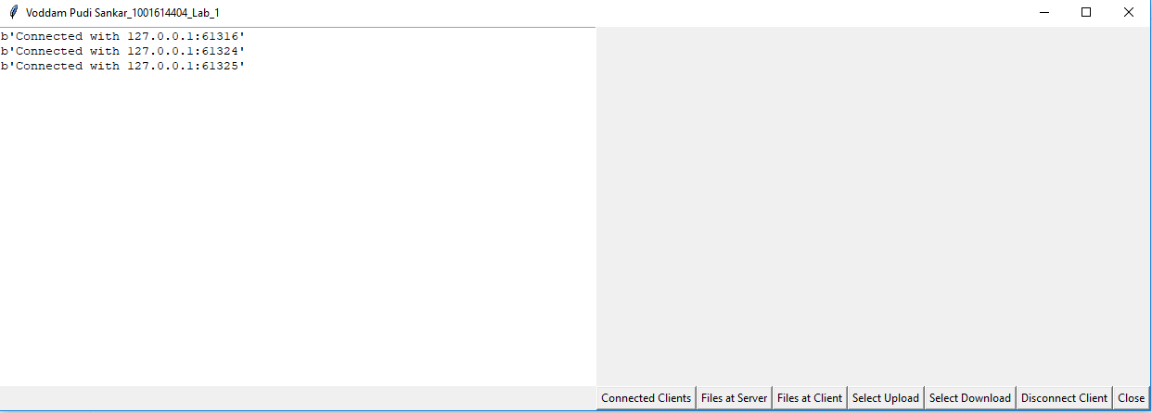

**File Upload or Download process:**

* Select the complete file name (i.e., highlight using mouse) along with the file extension.
* If extension is not displayed, select the full file name alone.
* Click on ‘Select Upload’ or ‘Select Download’ buttons to upload or download the file respectively.

A screen grab is provided below:

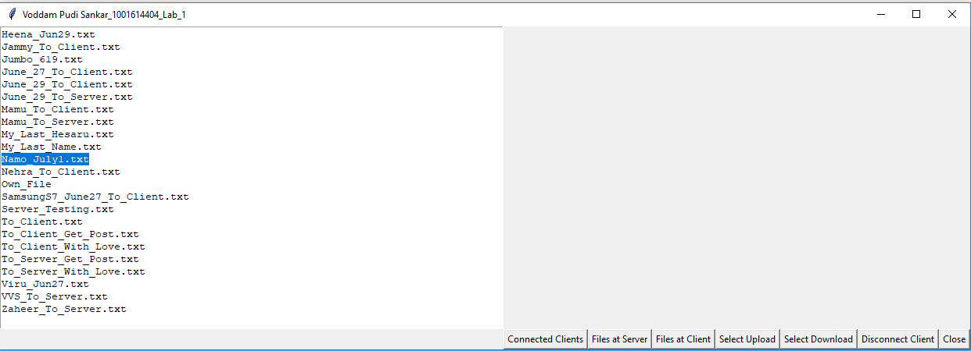

**Directory Description**

* Server Directory: C:\Users\Venkat\Desktop\DS Server Folder
* Client Directory: C:\Users\Venkat\Desktop\DS Client Folder

**IP and Port Descriptions**

* IP address:127.0.0.1
* Port number: 2346

**GUI description**

The buttons present in GUI are described below:

* **Connected Clients**: Shows the clients currently connected with the server.
* **Files at Server**: Shows the file available at the server (server directory).
* **Files at Client**: Shows the file available at the Client (Client directory).
* **Select Upload**: Uploads files present at the client to the server.
* **Select Download**: Downloads files present at the server to the client.
* **Disconnect Client**: Disconnects a connected client from server.
* **Close**: Safe closes the GUI.

**Assumptions and Limitations**

**In Server.py:**

* **s.listen(19)**—**Line 44**-- 19 is set as the upper bound for the number of waiting clients. If Client number 20 tries to connect to server, server will reject Clients 20s’ connection request.
* **split_data = data.split('\r')**—**Line 73—**The HTTP header is split by the character literal ‘\r’.
* **file_name_content = split_data[7].split('*')—Line 78—**File’s name and content are split by the character literal ‘*’ (asterik).
* Connected clients get displayed but an index error exception is generated when ‘Connected Clients’ button is clicked
* Clients get disconnected but an exception is generated when ‘Disconnect Client’ button is clicked.

**In Client.py:**

* **Lines 141 to 147**, and **lines 219 to 225:** Default HTTP header is used.

**References: (Documented in the source code as well)**

**In Server.py:**

<https://www.python-course.eu/sys_module.php>

<https://docs.python.org/2/library/thread.html>

<http://www.pythonforbeginners.com/os/pythons-os-module>

<https://www.binarytides.com/python-socket-programming-tutorial/>

[https://stackoverflow.com/questions/5104957/how-do-i-create-a-file-at-a-specific-path#](https://stackoverflow.com/questions/5104957/how-do-i-create-a-file-at-a-specific-path)

<https://www.guru99.com/reading-and-writing-files-in-python.html#1>

**In Client.py:**

<https://en.wikipedia.org/wiki/Tkinter>

<https://www.python-course.eu/sys_module.php>

<http://www.pythonforbeginners.com/os/pythons-os-module>

<http://www.pythonforbeginners.com/requests/using-requests-in-python>

<https://www.reddit.com/r/learnprogramming/comments/3vq0dm/python_how_can_i_print_text_out_in_the_gui_rather/>

<http://effbot.org/tkinterbook/text.htm>

<https://www.binarytides.com/python-socket-programming-tutorial/>

<https://stackoverflow.com/questions/3207219/how-do-i-list-all-files-of-a-directory>

<https://stackoverflow.com/questions/4073468/how-do-i-get-a-selected-string-in-from-a-tkinter-text-box>

<https://stackoverflow.com/questions/28670835/python-socket-client-post-parameters>

<https://en.wikipedia.org/wiki/List_of_HTTP_header_fields>